
MATHS METHODS (CAS) UNITS 3 & 4
TRIAL EXAMINATION 2
SOLUTIONS
2011

SECTION 1 – Multiple-choice answers

- D 9. A 17. A
- C 10. C 18. B
- C 11. D 19. D
- D 12. B 20. D
- B 13. C 21. E
- C 14. C 22. B
- A 15. E
- B 16. A

SECTION 1 – Multiple-choice solutions

Question 1

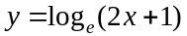
For this function to be defined,
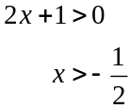
So maximal domain is 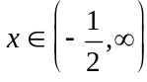.

The answer is D.

Question 2

Sketch the graph of 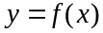, taking particular note of the domain.

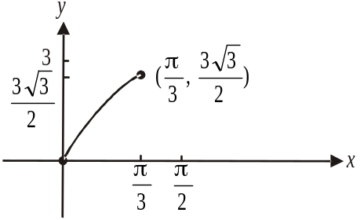
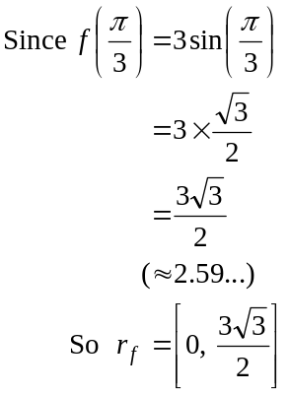

The answer is C.
Question 3

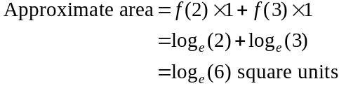
The answer is C.

Question 4

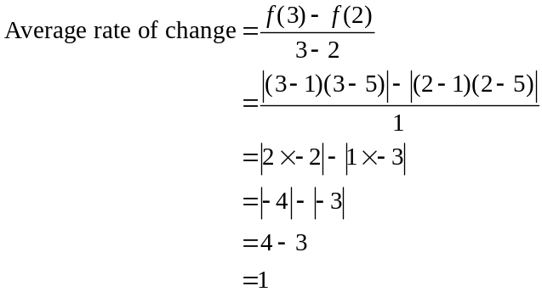

A quick sketch tells you that the first two answers are not feasible. We are looking for the gradient of the line segment joining the points where 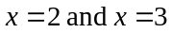 on the graph of 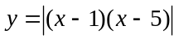.

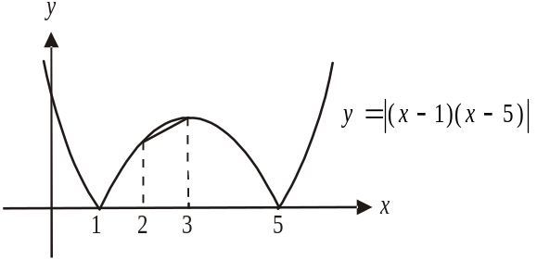

The answer is D.

Question 5

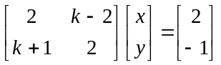

For no solutions or infinitely many solutions,

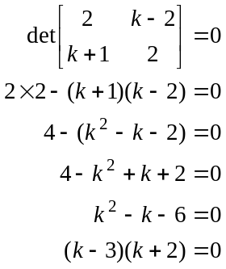

If , we have
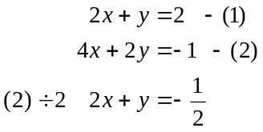
We have parallel lines so no solutions for .

If , we have
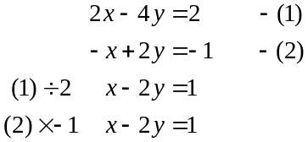
These equations represent the same line so infinite solutions for .
The answer is B.

Question 6

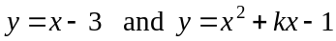
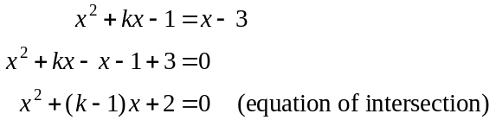
For no solutions; and therefore no points of intersection,
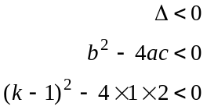
Method 1 – using CAS
Solve 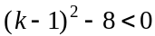 for k
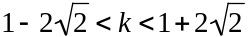
The answer is C.

Method 2 – by hand
Do a quick sketch of 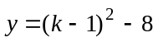.
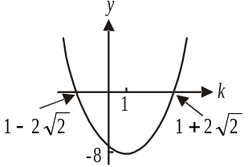
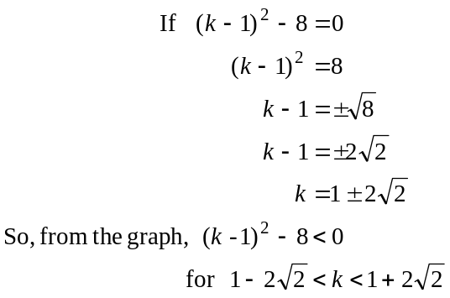
The answer is C.

Question 7

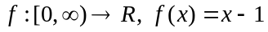

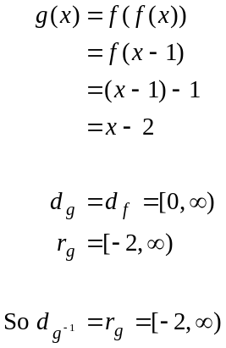
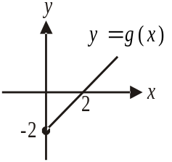
The answer is A.

Question 8

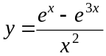
Using CAS,
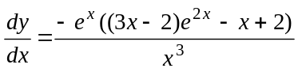
At 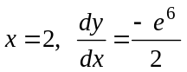.
The answer is B.

Question 9

Method 1 – using CAS

Let 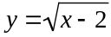
Swap x and y for inverse to obtain 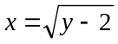and solve for y.
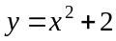 and 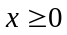

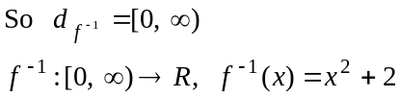

The answer is A.

Method 2 – by hand
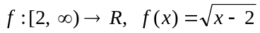
Let
Swap x and y for inverse.
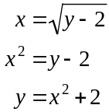
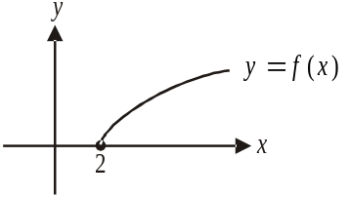
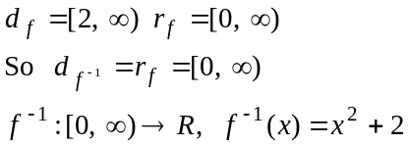
The answer is A.

Question 10

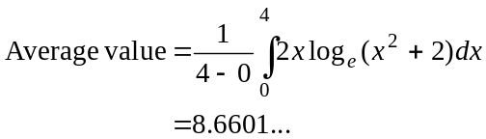
The closest answer is 8.66.
The answer is C.

Question 11

This is a binomial distribution with 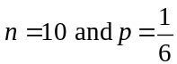.
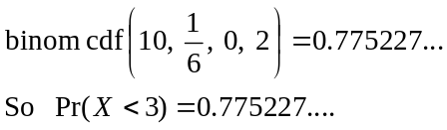
The closest answer is 0.7752.
The answer is D.

Question 12

So 6.68…% of people completing the survey did so in less than 20 minutes.
The closest answer is 6.7%.
The answer is B.

Question 13

Method 1
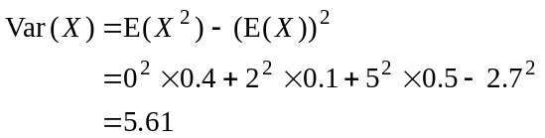
The answer is C.

Method 2

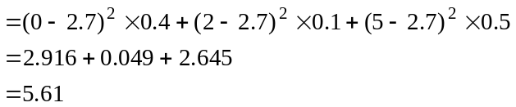
The answer is C.

Question 14

Method 1 – using CAS
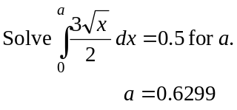
The answer is C.

Method 2 – by hand
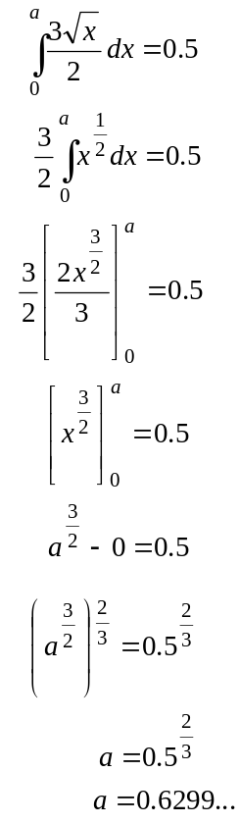
The answer is C.

Question 15

Sketch the function f.
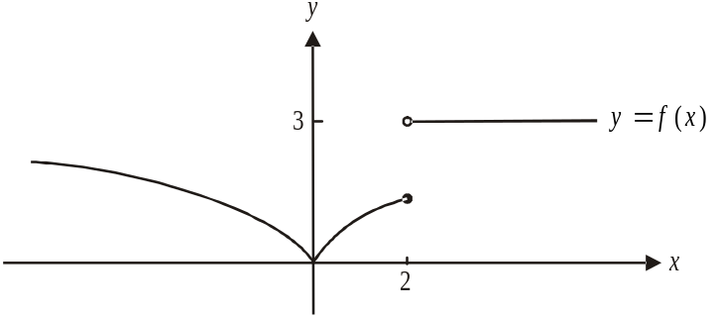

The derivative function 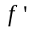 is defined for 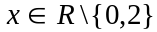.
The answer is E.

Question 16

Method 1 - using CAS
The equation of the tangent to the curve 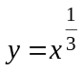 at the point where 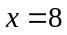 is given by
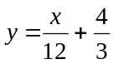.
The answer is A.
Method 2 – by hand
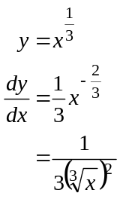
At
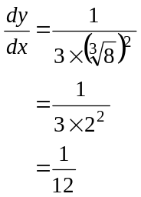
So 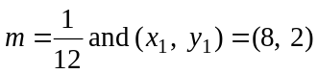
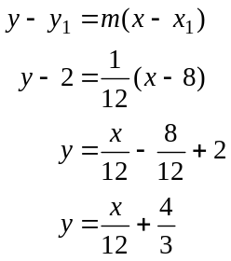
The answer is A.

Question 17
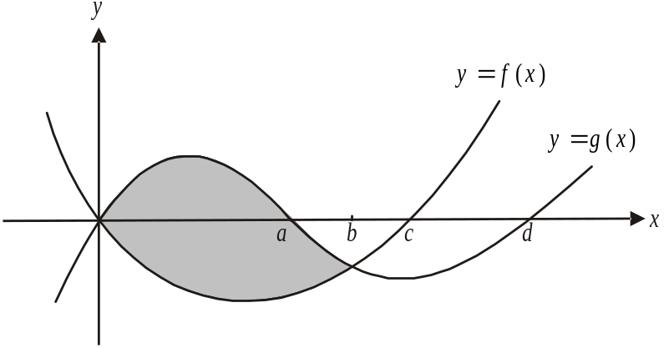

The area required is shaded.
The graphs of 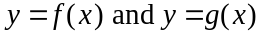 intersect at the points where . Over this interval 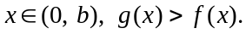
So area required 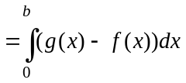.
The answer is A.

Question 18

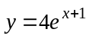
The graph of 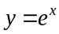 has been dilated from the x-axis by a factor of 4, and translated 1 unit to the left.
The rule could therefore be

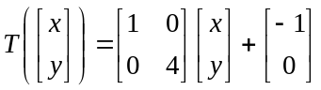
The answer is B.

Question 19
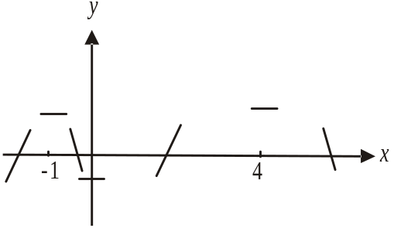
Stationary points occur where 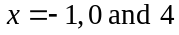.
The gradient is positive for .
The gradient is negative for .
So, there is a local maximum where
and a local minimum at .
Only option D is true.
The answer is D.

Question 20
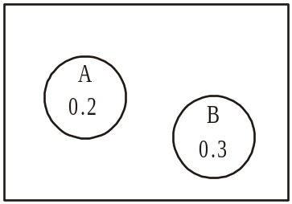
For mutually exclusive events 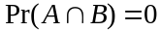
so option D is not true.
The other options can be verified using a
Venn diagram.
The answer is D.

Question 21

The graph of has been

- reflected in the x-axis
- dilated by a factor of from the y-axis
- translated 1 unit to the right
- translated 3 units up

to become the graph of
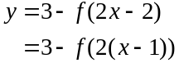
Only graph E shows this.
The answer is E.

Question 22
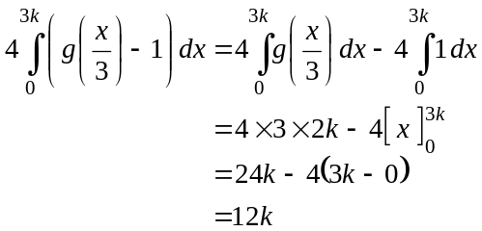
Note that the graph of 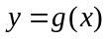 has been dilated by a factor of 3 from the y-axis to become the graph of 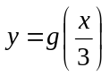 so if 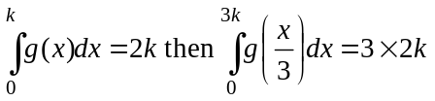.
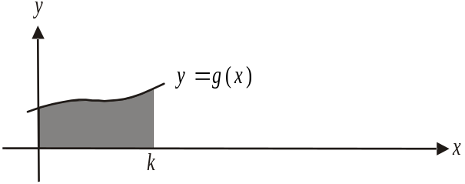

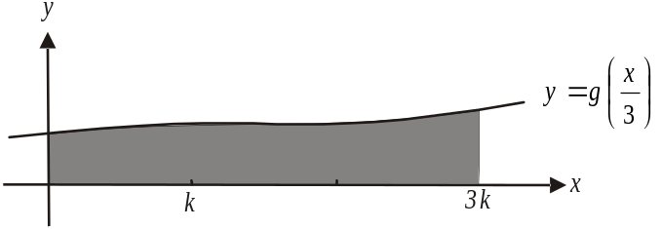

The answer is B.
SECTION 2

Question 1

- i. Method 1 – using CAS
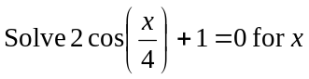 (1 mark)
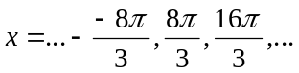
From the graph, we are looking for the second smallest positive value of x; that is, not the first positive x-intercept.
So 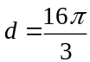.
(1 mark)

Method 2 – by hand
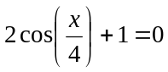 (1 mark)
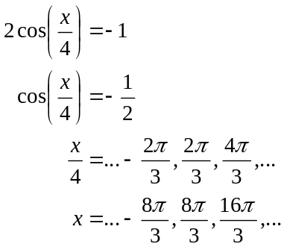
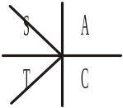
From the graph, we are looking for the second smallest positive value of x; that is, not the first positive x-intercept.
So .
(1 mark)

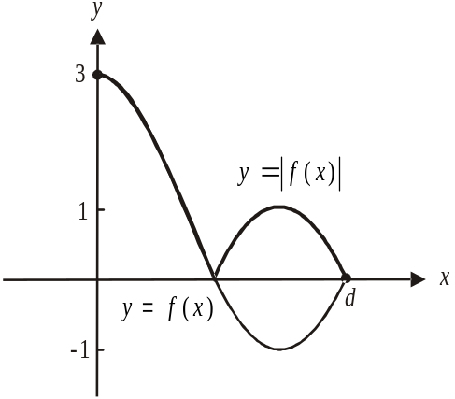

(1 mark)

- From the graph, the maximum value of 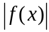 is 3.
(1 mark)
iv. Again from the graph, if 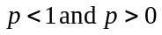 then there are three solutions to the
equation 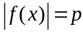.
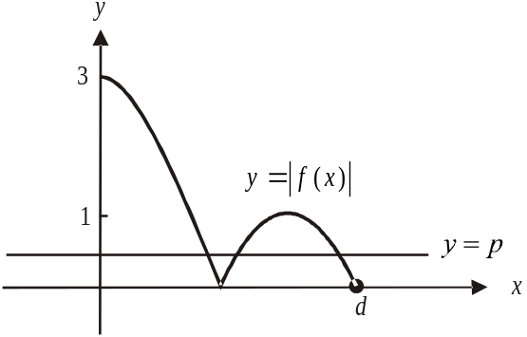

If 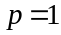, there are two solutions and if 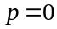 there are 2 solutions.
So 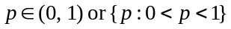.
(1 mark) – correct values
(1 mark) – endpoints excluded
- Method 1 – using CAS
Solve 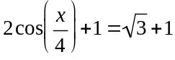 for x. (1 mark)

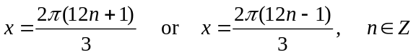
(1 mark) (1 mark)

Method 2 – by hand
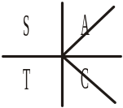
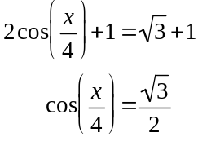
(1 mark)
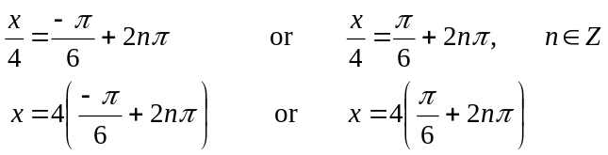
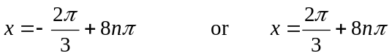
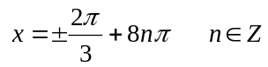
(1 mark) –first answer 1 mark) – second answer

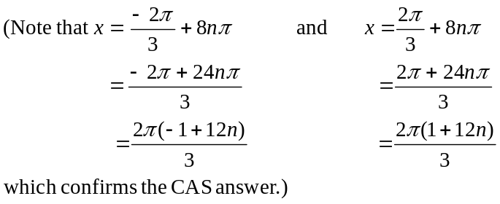

- i. 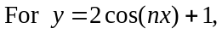
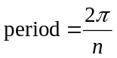
For 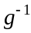 to exist, g must be 1:1
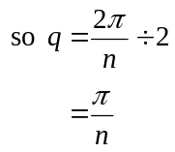
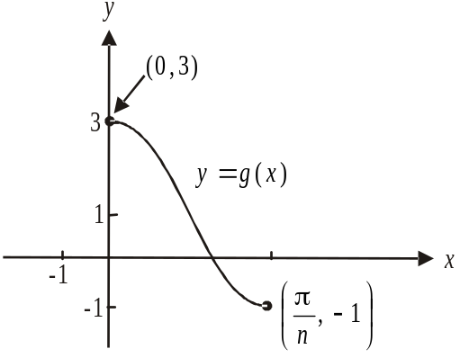

(1 mark) – correct value of q
(1 mark) – correct endpoints and shape

ii.
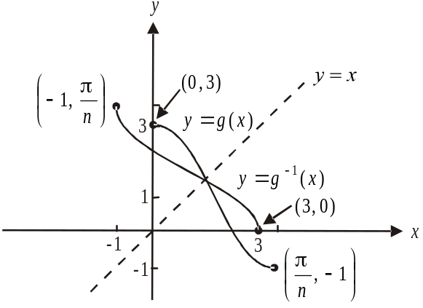

Note that the points 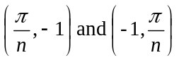 can be anywhere along the x-axis and y-axis respectively as long as the two axes are consistent.
(1 mark) – correct endpoints
(1 mark) – correct shape

- 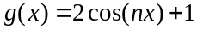
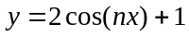
Since 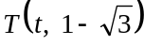 lies on g,
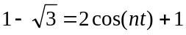 (1 mark)
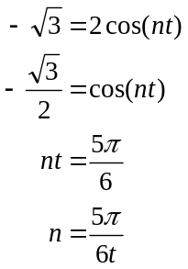
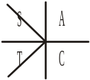
as required. (1 mark)

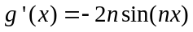 (1 mark)
At 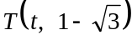
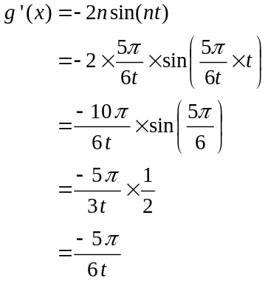

So the gradient of the normal to the graph of 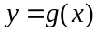 at the point
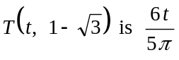. (1 mark)

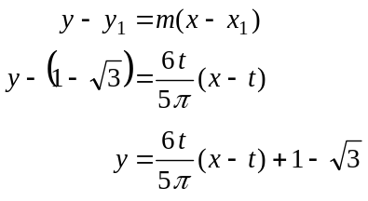
(1 mark)
Total 18 marks

Question 2

- Create a transition matrix.

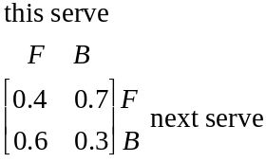

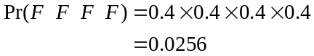
(1 mark)
- Method 1 – use the transition matrix
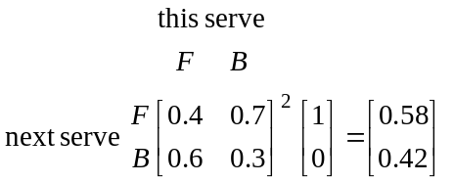
(1 mark)
The probability that the third serve was to her forehand is 0.58.
(1 mark)
Method 2 – use a tree diagram
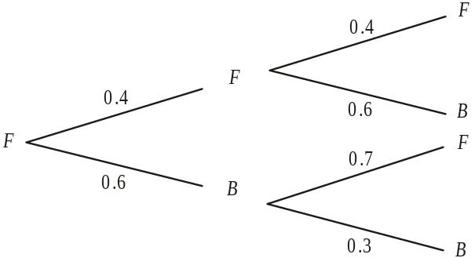

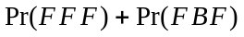 (1 mark)
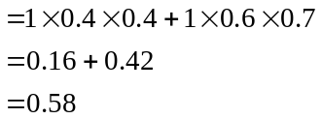
(1 mark)
- 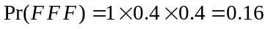
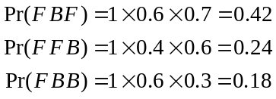
Set up a distribution table.
x | 0 | 1 | 2
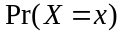 | 0.16 |  | 0.18
(2 marks)
(Check )
(1 mark)
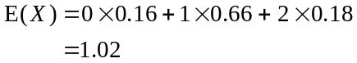
(1 mark)
- Method 1
Find the steady state.
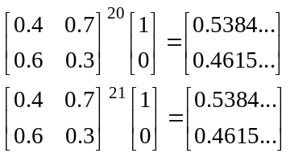
Steady state has been reached after 20 serves (maybe earlier).
In the long term 46%(to the nearest whole percent) of serves Sam received were to her backhand.
(1 mark)
Method 2
Let 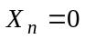 represent Sam receiving a forehand serve.
Let 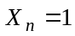 represent Sam receiving a backhand serve.
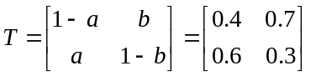
So 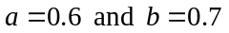.
For steady state, 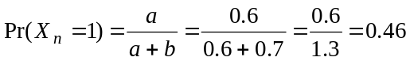
In the long term 46% of serves Sam received were to her backhand.
(1 mark)

- Method 1

The transition matrix for Wednesday is

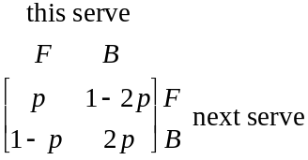

Solve
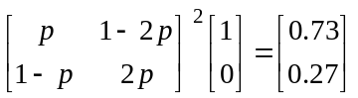 for p (1 mark)

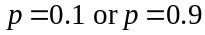 (1 mark)
but from the transition matrix since
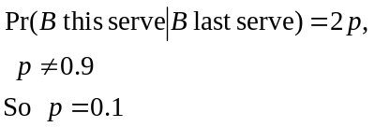
(1 mark)

Method 2

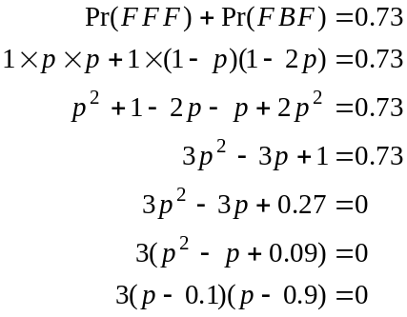
(1 mark)
(1 mark)
but from the transition matrix since
(1 mark)
    - i. 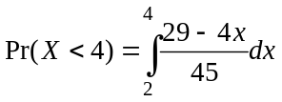
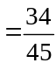
(1 mark)
- 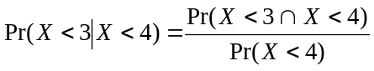
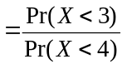
(1 mark)

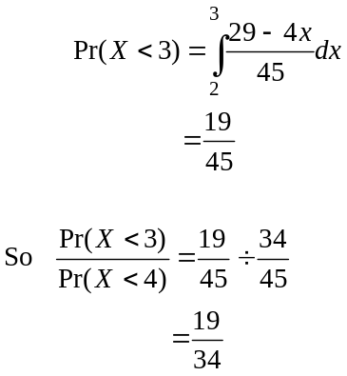
(1 mark)
Total 14 marks

Question 3

- 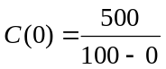
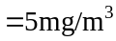
(1 mark)
- Since the function is continuous,
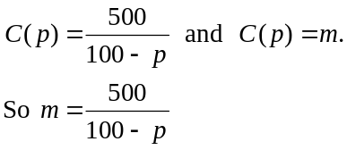
(1 mark)
- From the graph and part a., the minimum value of m is 5 which occurs when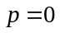.
(1 mark)
From the graph and part b., the maximum value of m must occur when 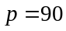 (since the function is continuous).
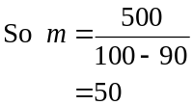
(1 mark)
- Method 1 – using CAS
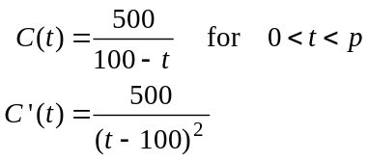
(1 mark)
Method 2 – by hand
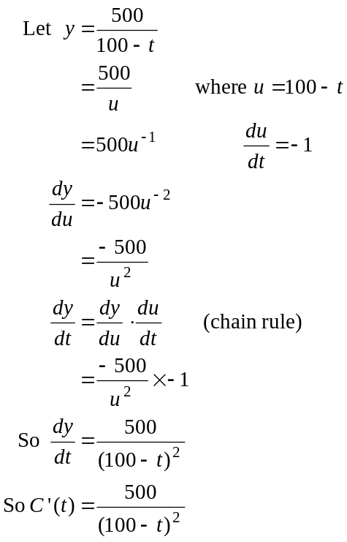 (1 mark)
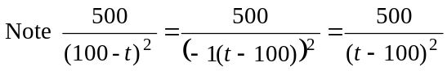 confirming the CAS answer above.

- Solve 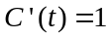
i.e. 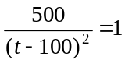 for t.
(1 mark)
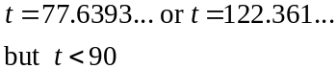
So minutes (correct to 2 decimal places)
(1 mark)

- 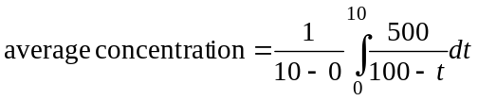 (1 mark)
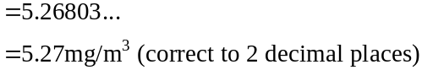
(1 mark)

- For the maximum concentration is m mg/m³.
From part b., 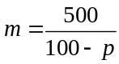.
For Victoria to survive, we require that

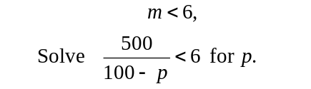
(1 mark)
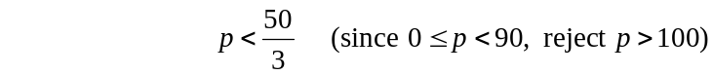
So in order for Victoria to survive, 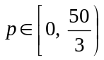.
(1 mark)
Total 11 marks

Question 4

- i. 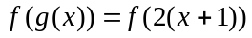
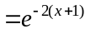
(1 mark)

- 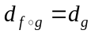
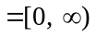
(1 mark)
To find 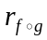 sketch the graph of 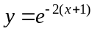 and restrict the domain to 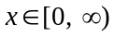.
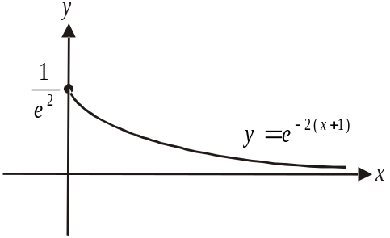

y-intercept occurs when
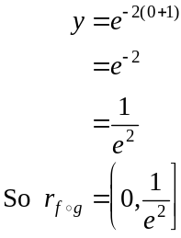
(1 mark) – correct left endpoint and bracket
(1 mark) – correct right endpoint and bracket

- 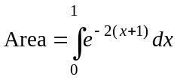 (1 mark)
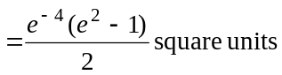
(1 mark)

- The graph of 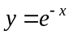 is
- dilated by a factor of from the y-axis and
- translated 1 unit left

to become the graph of
(1 mark) – description of dilation
(1 mark) – description of translation

- i. Stationary point occurs when 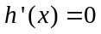. (1 mark)
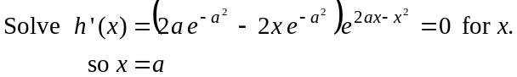
Since 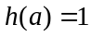, stationary point occurs at 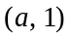.
(1 mark)

- 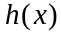 is strictly increasing for 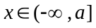.
(1 mark)

- 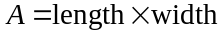
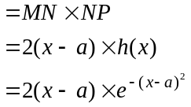
as required.
(1 mark)

- 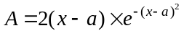
Maximum occurs when 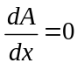.
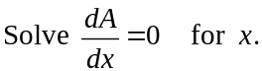 (1 mark)
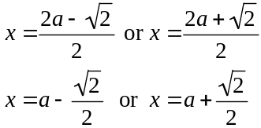
Since 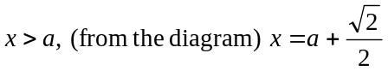
(1 mark)
Substitute 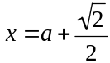 into 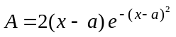.
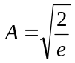
Maximum area is 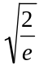 square units.
(1 mark)
Total 15 marks

